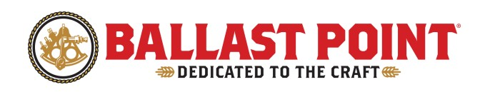
Ballast Point Production Operator I Position

Company Summary

We started out in 1996 as a small group of San Diego home brewers who simply wanted to make a better beer. In our exploration, we became obsessed with ingredients—tinkering, testing and tasting to find the perfect balance of taste and aroma. That adventurous spirit leads to award-winning beers in classic and unique styles while challenging our own tastes and expanding yours.

We’re proud of our San Diego roots, our employees, our beers, and our fans. We think of our employees as family, and you, our fans, as extended family. You’ll see us use #BPPROUD as a badge of pride and a way to further connect with our beer loving community.

Position Summary

Production Operators are responsible for operating and maintaining equipment and product on our packaging lines. This includes manual and automated operation of high-speed filling, packaging, and palletizing equipment. Production Operators are responsible for maintaining high standards of quality in every aspect of their job. Some employees work directly with our product and will be trusted with proprietary information regarding our specifications. Our Production Operators will execute excellent customer service to their peers, managers, vendors, other departments, consumers, and other applicable affiliates. The ideal candidate must be dependable, responsible and be able to uphold Ballast Point’s Mission and Values.

Key Responsibilities

- Successfully operate packaging line equipment (canning, bottling, and kegging lines)
- Preparing products for packaging, including manual repacks as needed
- Learning and preserving Ballast Point quality standards
- Maintaining a clean and safe work environment following OSHA, 5S, and other established company guidelines
- Ability to follow instructions and meet business needs based on daily goal changes when necessary
- Performing minor preventative and troubleshooting maintenance on all machinery with regard to safety, quality, waste monitoring, recordkeeping; escalating repairs to Facilities Technicians as needed
- Supporting other departments as needed with moving equipment, loading, and unloading of product and packaging materials

Minimum Qualifications

- Schedule flexibility to work days, evenings, grave shift, with overtime, holiday, alternative work weeks and weekend shifts as needed
- Some previous packaging experience is ideal
- Forklift operation skills
- Strong oral and written communication skills
- The ability to work independently, as well as with others in a team-based setting

Preferred Qualification

- Prior beverage manufacturing experience
- Forklift certification
- Mechanical aptitude

Physical Requirements/Work Environment

- This is a full-time position requiring the ability to work at least 8 hours daily
- Ability to lift at least 20+ pounds
- Required standing for long periods of time, as well as regular walking, bending, and stooping
- Regular use of hands to handle, touch, and manipulate equipment, including reaching with hands and arms at various heights
- Willingness to work in varying temperature conditions
- Willingness to work in an industrial warehouse environment around various machinery, forklift traffic, and loud noises
- Ability to work safely with potentially hazardous chemicals

Travel

No travel is required for this position.

Other Duties

Please note this Job Description is not designed to cover or contain a comprehensive listing of activities, duties, or responsibilities that are required of the employee for this job. Duties, responsibilities, and activities may change at any time with or without notice.

Ballast Point Brewing Company is an Equal Opportunity Employer.

